

**AI-B(24)**

**ICAT PROJECT**

**AI Powered E-Com Website**

|  |
| --- |
| **Members:** |
| **Ismail Shah** |
| **Muhammad Rehan** |
| **Muhammad Moeen** |
| **Muhammad Inshal Rabbani** |
| **Muhammad Anas** |

## AI-Powered E-Commerce Website

## ****1. Introduction****

The AI-powered e-commerce website is designed to enhance online shopping experiences by integrating artificial intelligence. The platform features a dynamic product catalog, an AI-powered chatbot for customer support, and multiple interactive pages to facilitate seamless transactions.

One of the standout features of this website is the chatbot, which is integrated using **Chatbase.co**. It provides **real-time customer assistance** and **personalized product recommendations** based on user behavior. The website structure includes **twelve core pages**, each contributing to a smooth user experience.

This project aims to provide a **modern, efficient, and AI-driven** shopping platform that improves user engagement and increases convenience.

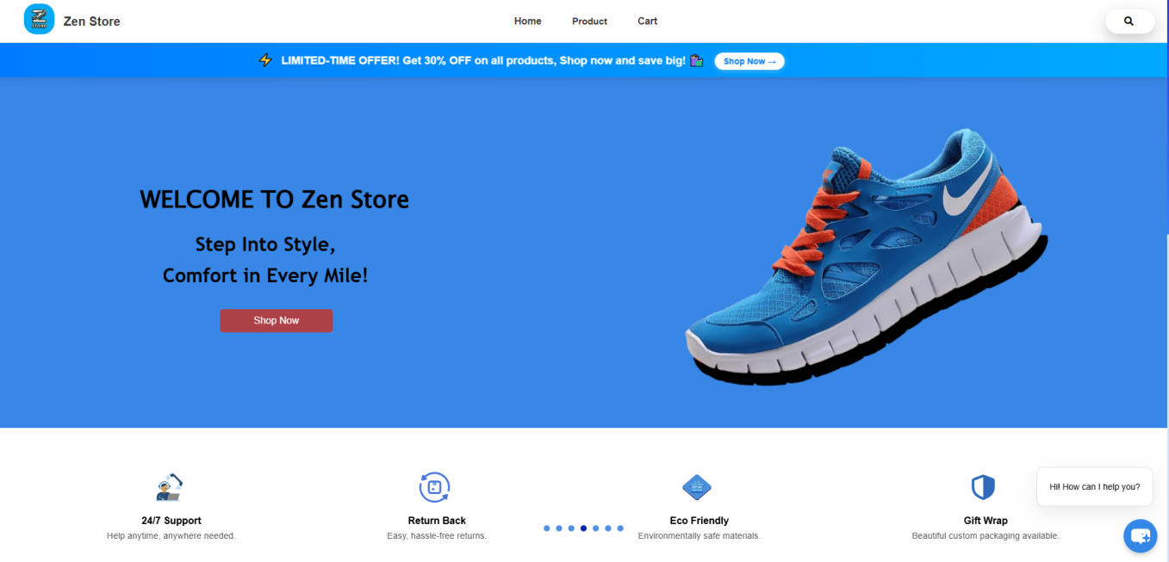

## ****2. Key Features****

The e-commerce website consists of multiple features that enhance user experience and streamline the online shopping process:

### **Core Website Features:**

* **Dynamic Product Categories:**
  + Separate product pages for **Men, Sports, and Women** categories, all dynamically generated.
* **Single Product Description Page:**
  + A **universal product details page** that dynamically displays information for all listed products.
* **Shopping Cart System:**
  + Users can add, remove, and view products in their cart before proceeding to checkout.
* **Secure Checkout Process:**
  + A smooth checkout experience ensuring that users can complete transactions without friction.
* **User Authentication:**
  + **Login and Signup pages** for creating and managing user accounts.

### **Admin Panel Features:**

* **Order Management:**
  + The admin panel allows administrators to **approve or reject orders** based on payment confirmation.
* **Payment Handling:**
  + The system includes **Cash on Delivery** and **Easy-Paisa manual payments**, where the admin verifies payments.

### **AI Integration Features:**

* **AI Chatbot for Customer Support:**
  + Integrated via **Chatbase.co**, providing **real-time responses** and **personalized recommendations** to users.

## ****3. Literature Review (Existing Work)****

Many **popular e-commerce platforms**, such as **Amazon, Shopify, and eBay**, have implemented AI-driven features to enhance user experience. AI is used in various aspects of online shopping, including:

* **Personalized Recommendations:**
  + Platforms like **Amazon and Netflix** use AI to analyze user preferences and suggest products or content.
* **Chatbots for Customer Support:**
  + Companies like **H&M and Sephora** have AI-driven chatbots to handle customer inquiries, reducing the need for human support.
* **Smart Search Algorithms:**
  + AI-powered search engines improve product discoverability through advanced filters and image recognition.

This project incorporates these AI-driven methodologies, **adapting them to a dynamic e-commerce setting** with a **user-friendly, interactive chatbot and a streamlined shopping experience**.

## ****4. Reason for Choosing the Project****

The decision to develop an **AI-powered e-commerce website** was driven by the rapid growth of online shopping and the increasing role of AI in enhancing customer experience. **Key motivations include:**

1. **Growing Market Demand:**
   * The global e-commerce industry is **booming**, and AI integration gives businesses a competitive advantage.
2. **Customer Personalization:**
   * AI chatbots provide **real-time assistance**, reducing the need for human customer support.
3. **Automation & Efficiency:**
   * Automating product recommendations, order processing, and payment verification makes the system **more efficient**.
4. **Hands-On Experience with AI & Web Development:**
   * This project allowed the implementation of **cutting-edge AI solutions** in an interactive online store.

## ****5. Future Work****

While the current version of the AI-powered e-commerce website is functional, several improvements can enhance its capabilities:

1. **Advanced AI Chatbot Capabilities:**
   * Implement **machine learning-based recommendations** to personalize user experiences even further.
2. **Augmented Reality (AR) Shopping:**
   * Allow users to **visualize products in real life** before making a purchase.
3. **Blockchain-Based Secure Payments:**
   * Introduce **cryptocurrency payments** and **blockchain verification** for added security.
4. **Voice Search Integration:**
   * Enable users to search for products using **voice commands** instead of typing.
5. **AI-Powered Fraud Detection:**
   * Implement fraud detection systems to **identify suspicious transactions and prevent fraud**.

### **Conclusion**

This **AI-powered e-commerce website** is a **step toward the future** of online shopping, where artificial intelligence plays a crucial role in enhancing customer interactions. With **real-time chatbot support, personalized recommendations, and a streamlined shopping experience**, this project lays the foundation for a more **efficient and intelligent e-commerce platform**. Future enhancements such as **voice search, AR shopping, and blockchain payments** will further improve the system, making it a **cutting-edge solution** in the e-commerce industry.